CO2

1. **Program to find the factorial of a number**

n=int(input("Enter the Number"))

f=1

for i in range(1,n+1):

f=f*i;

print("Factorial of ",n,"is",f)

**OUTPUT**

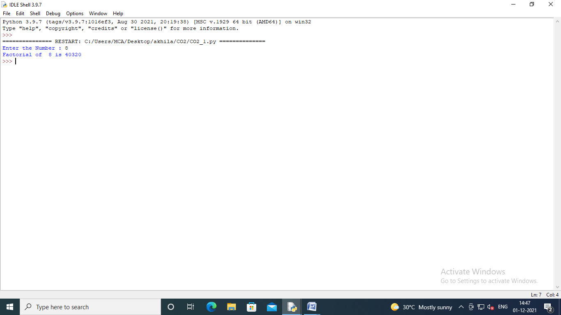

1. **Generate Fibonacci series of N terms**

n=int(input("Enter the Limit : "))

a=0

b=1

sum=0

count=1

print("Fibnocci Series :",end=" ")

while(sum<=n):

print(sum, end=" ")

count+=1

a=b

b=sum

sum=a+b

**OUTPUT :**

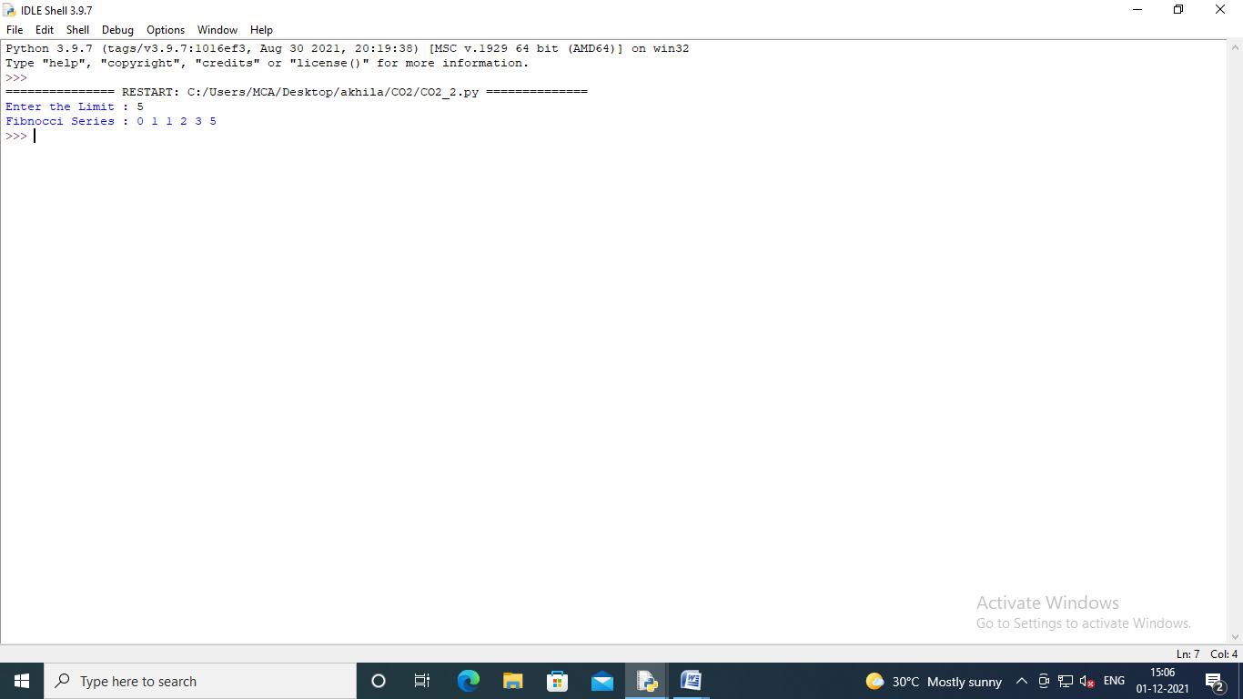

1. **Find the sum of all items in a list**

list=[10,20,30]

print("List is",list)

total=sum(list)

print("Sum of List is : ",total)

**OUTPUT:**

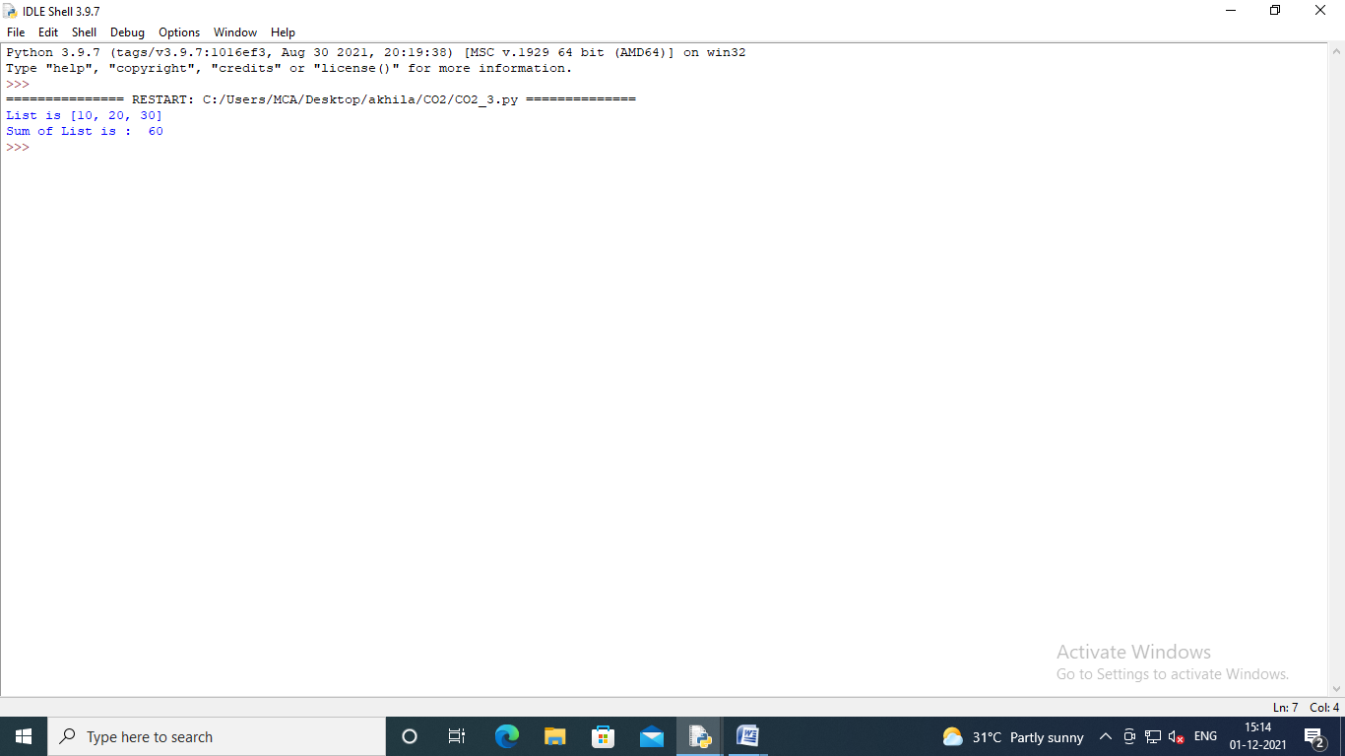

1. **Generate a list of four digit numbers in a given range with all their digits even and the number is a perfect square.**

from math import sqrt as s

for i in range(1000,10000):

if s(i)==int(s(i)) and i%2==0:

print(i,end=" ")

**OUTPUT:**

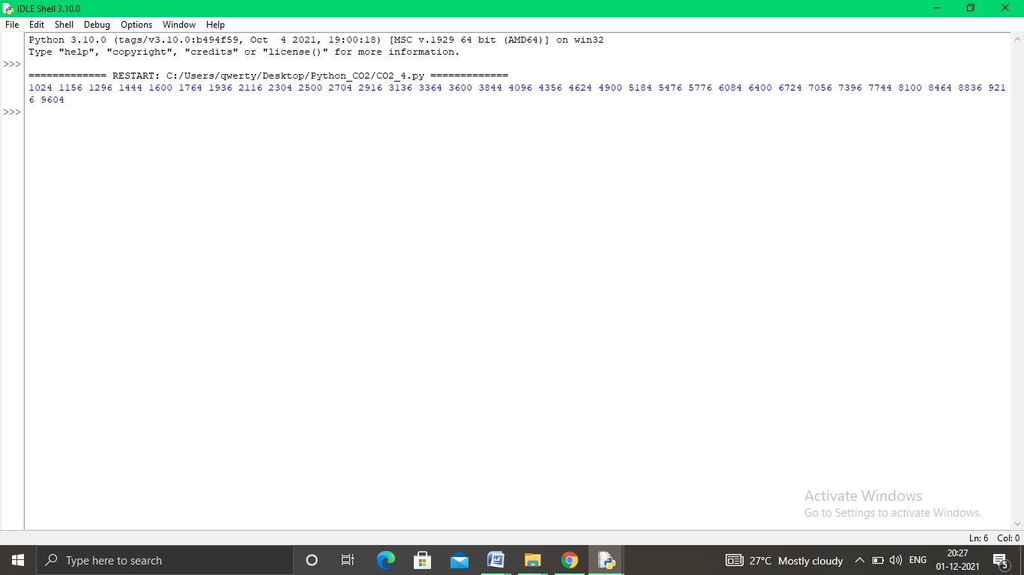

**5.Display the given pyramid with step number accepted from user.**

rows = int(input("Enter the number of rows: "))

for i in range(1, rows+1):

for j in range(1,i+1):

print(i*j, end='')

print()

**OUTPUT:**

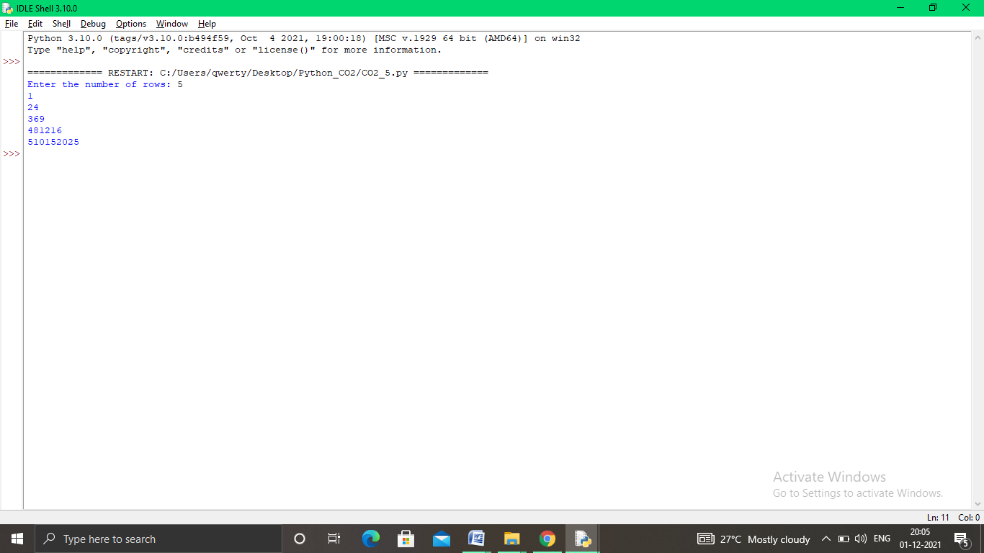

**6.Count the number of characters (character frequency) in a string.**

str1=str(input("Enter a string :"))

freq={}

for i in str1:

if i in freq:

freq[i]+=1

else:

freq[i]=1

print("Count of all character : "+str(freq))

**OUTPUT**

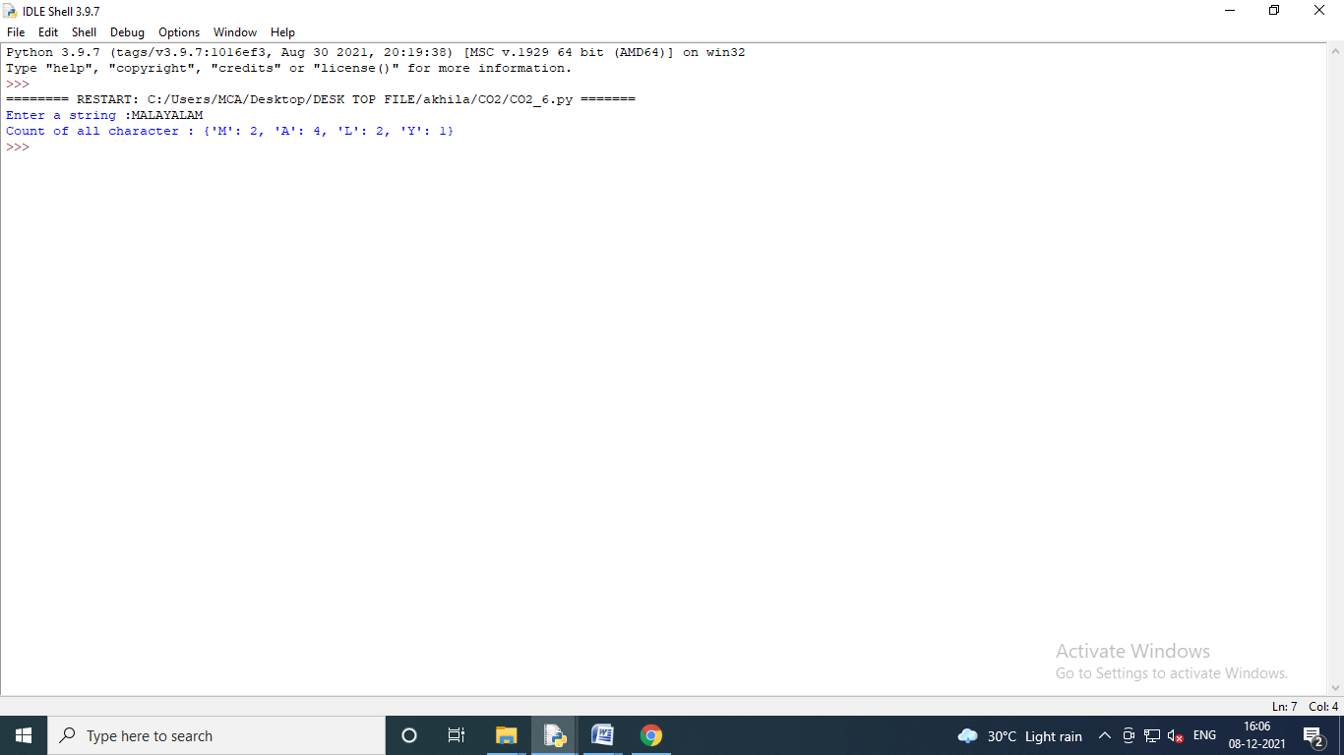

**7.Add ‘ing’ at the end of a given string If it already ends with ‘ing’ ,then add ‘ly’**

str=input("Enter a string:")

print("Inputed string is:",str)

if(str.endswith("ing")):

str=str+'ly'

else:

str=str+'ing'

print("The formated string is:",str)

**OUTPUT:**

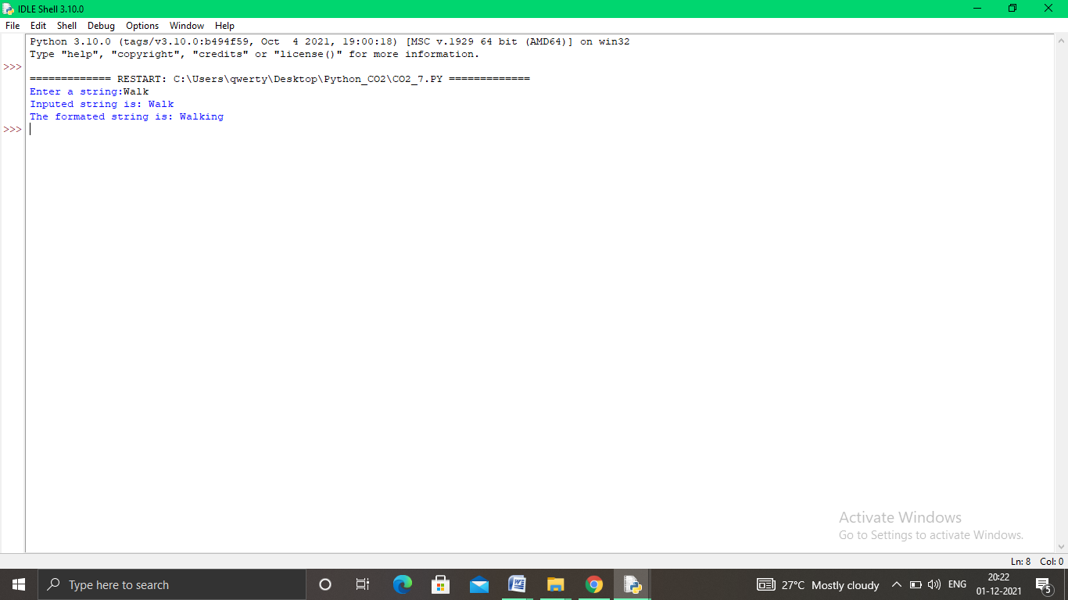

**8. Accept a list of words and return length of longest word.**

a=[]

n= int(input("Enter the number of elements in list:"))

for x in range(0,n):

element=input("Enter element "+ str(x+1) )

a.append(element)

max1=len(a[0])

temp=a[0]

for i in a:

if(len(i)>max1):

max1=len(i)

temp=i

print("Longest Word:",temp)

print("Length of longest word :",max1)

**OUTPUT:**

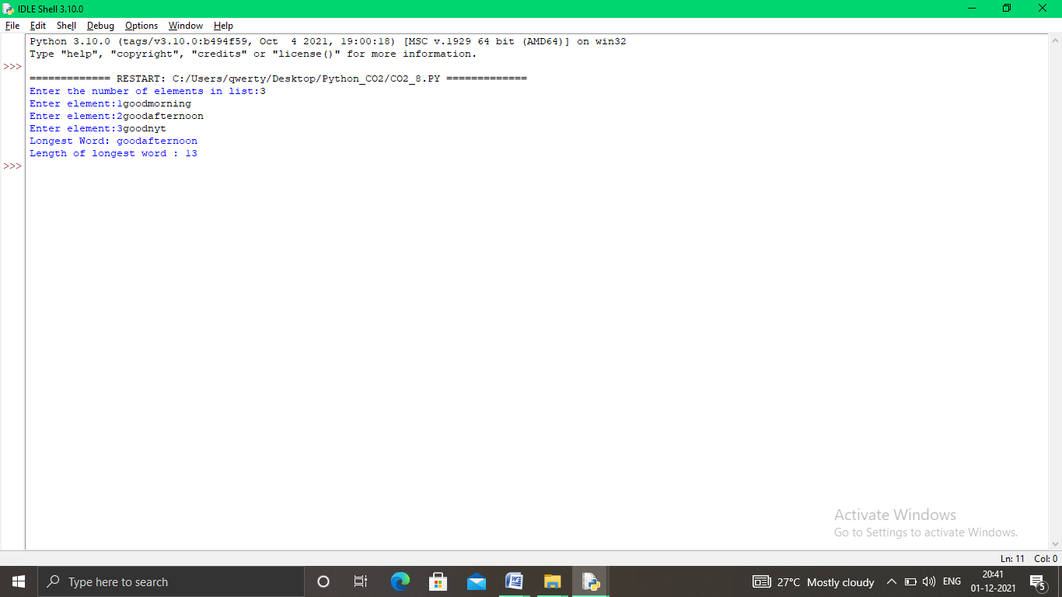

**9.** **Construct following pattern using nested loop**

n= int(input("Enter the limit:"))

for i in range(n):

for j in range(i):

print ('* ', end="")

print('')

for i in range(n,0,-1):

for j in range(i):

print('* ', end="")

print('')

**OUTPUT:**

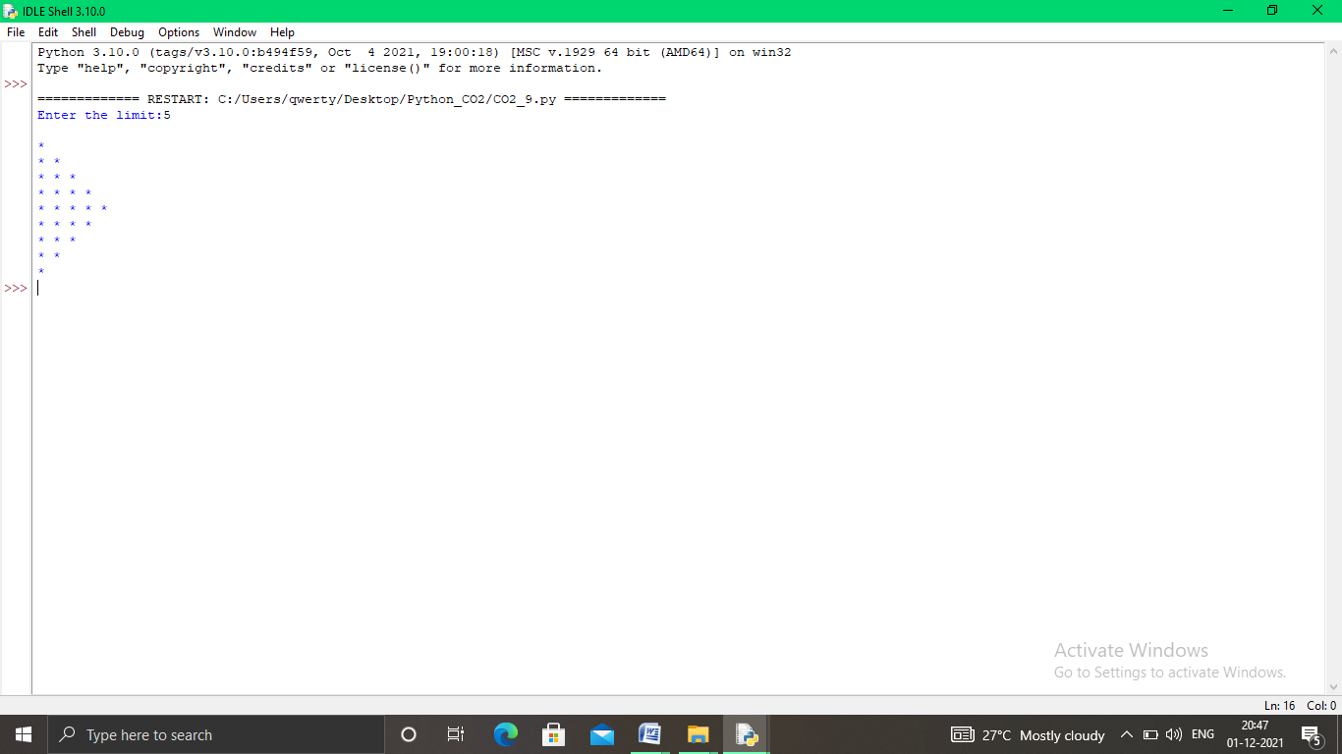

**10. Generate all factors of a number. def print_factors(x):**

def factors(x):

print("Factor of ",x,"are")

for i in range(1,x+1):

if x%i==0:

print(i)

n=int(input("Enter a Number : ") )

factors(n)

**OUTPUT**

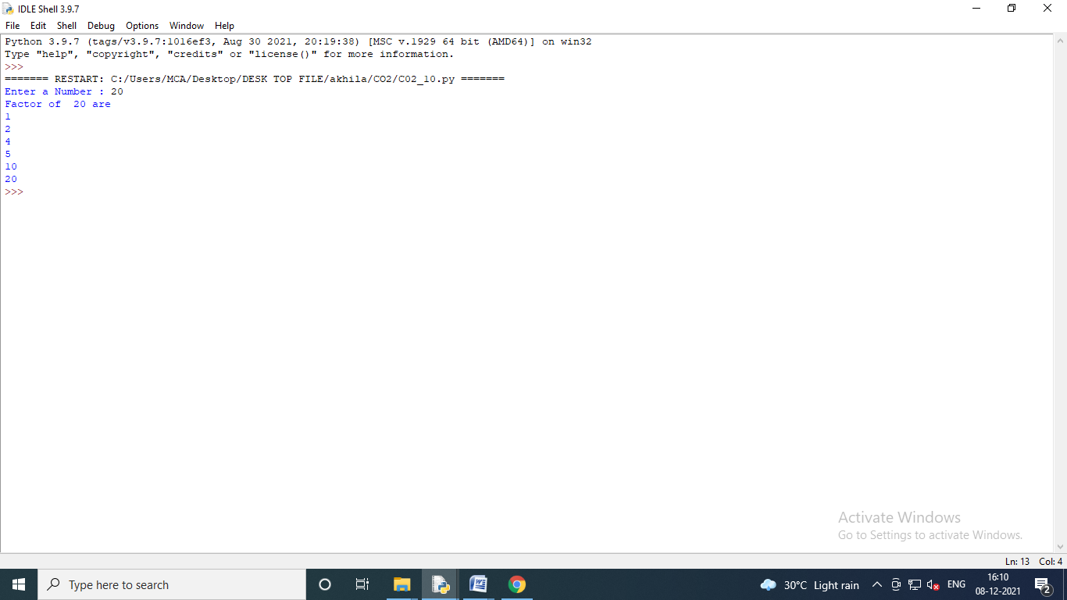

**11.Write lambda functions to find area of square, rectangle and triangle.**

import math

triangle_area =lambda b,h:1/2*b*h

rectangle_area =lambda l,b:l*b

square_area =lambda a:a*a

print("Area of Triangle = ",triangle_area (2,4))

print("Area of Rectangle = ",rectangle_area(3,4))

print("Area of Square = ",square_area(4))

**OUTPUT :**

